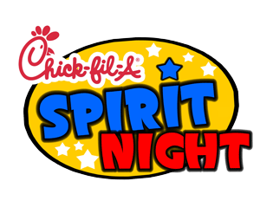

Please come out to Chick-fil-A in Troy, September 16^{th,} 2014 from 5:00p.m. - 8:00p.m. to show your spirited support for Pike County Elementary School. Ten percent of all proceeds that night will be donated to help our school raise money for the Technology, Math and Science departments. Tell a friend! Tell a neighbor! Bring the family! Purchases can be made through the drive-thru or in the dining area. To participate, please tell the cashier “I’m here to support Spirit Night,” when making your purchase.
Don’t forget to wear purple or your favorite Pike County Bulldog Shirt!
When: September 16th, 2014
Time: 5:00p.m. -8:00 p.m.
Where: Chick-fil-A (Troy Location)
Why: P.C.E.S. KIDS DESERVE OUR BEST!

We Appreciate Your Support!

